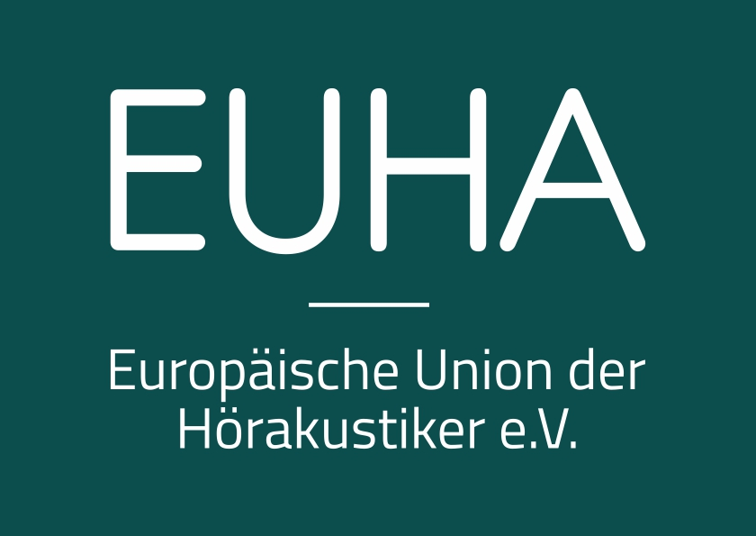
+++ Press release +++

EUHA TV: Lectures of the 2021 EUHA Congress available online now
(EUHA/Mainz, 18 November 2021) Further education and advanced vocational training no matter where, no matter when – watch out for EUHA TV! The lectures given at the 65th International Congress of Hearing Aid Acousticians are now available on EUHA TV at www.euha.tv.
EUHA TV was launched in 2016, and has since been used by acousticians to acquire knowledge at home or on the go, and to deepen individual topics after the Congress. The tool is ideal for anyone who wishes delve into specific topics, allowing hearing aid acousticians to combine individual training with flexibility. The lectures are offered in the original languages and also contain the presentation slides.
Access is free of charge to holders of Congress season tickets and one-day combi tickets. Online access can be booked by going to www.euh.org or www.euha.tv. Special conditions apply to EUHA members and their employees. Online access will be open until 11 October 2022. The lectures held during the opening of the Congress as well as the Future Friday presentations are available free of charge to anyone interested.

Fees
EUHA members and their employees
up to 9 registrations 49.00 euros
from 10 registrations 39.00 euros
from 50 registrations 29.00 euros

Non-members
per registration 69.00 euros
Holders of a season ticket
or one-day combi ticket free of charge

Contact
Europäische Union der Hörakustiker e. V.
Sabine Stübe-Kirchhof
Saarstraße 52
55122 Mainz
Germany
Phone: +49 (0) 61 31 / 28 30-14
Fax: +49 (0) 61 31 / 28 30-30
E-mail: presse@euha.org
Web: www.euha.org
www.facebook.com/EUHAeV/
www.instagram.com/euhaev/
www.linkedin.com/company/euha-ev
www.xing.com/xbp/pages/europaeische-union-der-hoerakustiker-e-v

